EX-1:

CREATE VIEW view_employees

AS SELECT emp_id,emp_name

FROM emp

WHERE emp_id BETWEEN 100 and 124;

SELECT * FROM view_employees;

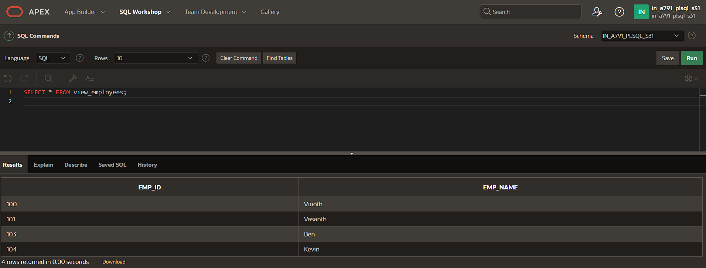

EX-2:

CREATE OR REPLACE VIEW view_euro_countries AS SELECT country_id AS "ID", country_name AS "Country", capitol AS "Capitol City" FROM wf_countries WHERE location LIKE '%Europe';

EX-3:

CREATE OR REPLACE VIEW view_high_pop

("Region ID", "Highest Population")

AS

SELECT region_id AS "Region ID", MAX(population) AS "Highest Population"

FROM wf_countries

GROUP BY region_id;

SELECT * FROM view_high_pop;

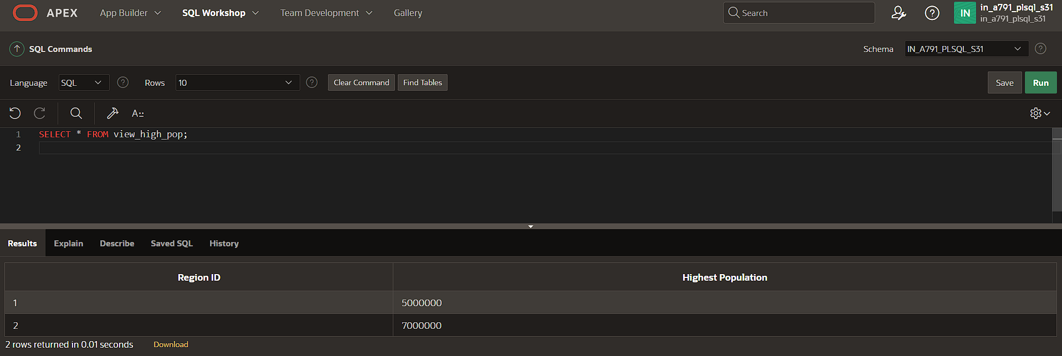

EX-4:

CREATE OR REPLACE VIEW view_euro_countries

AS

SELECT country_id, region_id, country_name

FROM wf_countries

WHERE country_name LIKE '%Europe%';